Network Traffic

🌐 What is Network Traffic?
# Source: Chatgpt (GPT‑5 Mini) at [12/9/2025]
Network traffic refers to the flow of data over a computer network. It includes all the data packets that are sent and received by devices such as computers, servers, routers, switches, and other networked equipment.
✅ In simple terms: Network traffic = data moving across a network.

📦 What Does It Include?
# Source: Chatgpt (GPT‑5 Mini) at [12/9/2025]
Network traffic includes all types of data communication, such as:
- 📄 File transfers (e.g., downloading a PDF)
- 🌍 Web browsing (HTTP/HTTPS)
- 📧 Emails (SMTP, IMAP)
- 🎥 Video streaming (YouTube, Netflix)
- 🕹️ Online gaming
- 📞 Voice and video calls (VoIP, Zoom)
- 📡 IoT device communication

🔄 Types of Network Traffic
# Source: Chatgpt (GPT‑5 Mini) at [12/9/2025]
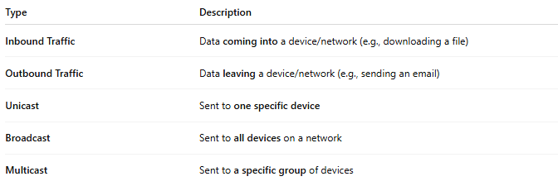

Type | Description
Inbound Traffic | Data coming into a device/network (e.g., downloading a file)
Outbound Traffic | Data leaving a device/network (e.g., sending an email)
Unicast | Sent to one specific device
Broadcast | Sent to all devices on a network
Multicast | Sent to a specific group of devices

🔍 Why Is Network Traffic Important?
# Source: Chatgpt (GPT‑5 Mini) at [12/9/2025]
- 📊 Performance Monitoring – Check for congestion or bottlenecks
- 🔐 Security Monitoring – Detect hacking attempts, malware, unusual activity
- 📈 Capacity Planning – Know when to upgrade bandwidth or hardware
- 🧩 Troubleshooting – Find out why a network or app is slow or unresponsive

🧠 Common Terms Related to Network Traffic
# Source: Chatgpt (GPT‑5 Mini) at [12/9/2025]
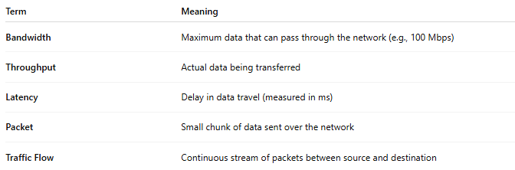

Term | Meaning
Bandwidth | Maximum data that can pass through the network (e.g., 100 Mbps)
Throughput | Actual data being transferred
Latency | Delay in data travel (measured in ms)
Packet | Small chunk of data sent over the network
Traffic Flow | Continuous stream of packets between source and destination

⚠️ Problems Caused by Excess Traffic
# Source: Chatgpt (GPT‑5 Mini) at [12/9/2025]
- Slowness or lag in applications
- Dropped connections
- Packet loss
- Security risks (e.g., DDoS attacks)
- Overloaded servers or routers

📌 Summary
# Source: Chatgpt (GPT‑5 Mini) at [12/9/2025]
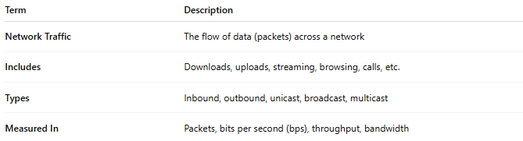

Term | Description
Network Traffic | The flow of data (packets) across a network
Includes | Downloads, uploads, streaming, browsing, calls, etc.
Types | Inbound, outbound, unicast, broadcast, multicast
Measured In | Packets, bits per second (bps), throughput, bandwidth

